# Models for synchrophasor with step discontinuities in magnitude and phase, their parameter estimation and performance

Marcelo Britto Martins*, Renata Teixeira de Vasconcellos*, Paulo Antonio Andrade Esquef†

### *National Institute of Metrology, Quality and Technology - Inmetro

mbmartins@inmetro.gov.br, rbvasconcellos@inmetro.gov.br

†National Laboratory for Scientific Computing – LNCC

pesquef@lncc.br

### *Abstract* — This work proposes an alternative method to assess the calibration of phasor measurements units (PMUs) under conditions of step discontinuities in magnitude or phase. Two parametric mathematical models are used to represent the signal and an iterative numerical method is used to best fit the model parameters to the samples. This approach avoids the adjustment of time windows around the instant of the discontinuity. The estimated parameters can be used to calculate a reference phasor with an appropriate definition. Expand a little more

Frequency estimation has an important role

### *Index Terms* — Calibration, dynamic tests, phasor measurement units, synchrophasor, uncertainty.

### I. Introduction

PMU calibration systems must be able to perform phasor magnitude tests and phase step tests on PMUs to evaluate their response under dynamic conditions [1]. The accuracy of those measurements depends on the reference values provided by the calibration system, obtained by synchronously generating and sampling standard test signals. Recent developments towards the calibration of PMUs for distribution systems demand even lower uncertainty levels [2].

A stationary phasor waveform can be curve fitted with a steady state sinusoidal function with good accuracy. However, in the specific case of an observed phasor disturbed by a step discontinuity in magnitude or phase, there is a lack of definition of what the reference phasor should be. To overcome this difficulty, the method used in [3] adjusts the timestamp and position of the analysis window to skip the discontinuity and set the phasor estimates where the discontinuity occurs with those of obtained from the previous window. That way, it avoids the mathematical modelling of a step discontinuity.

Methods for a more detailed analysis of calibration systems under step conditions are proposed in [4], using a pointwise root mean squared error. Although not trying to break the stationary paradigm of the phasor representation of a signal, we propose an alternative approach to evaluate the measurements by means of intermediate phasor estimates, which can be used as reference values for calibrations and easily implemented in the existing systems, in place of traditional estimation schemes.

This work is an extended version of [5]. It offers the following contributions: 1) synchrophasor models that account for step discontinuities in magnitude or phase; 2) a method to estimate the instant of step discontinuity; 3) a way to estimate model parameters by means of a nonlinear least-square method (NL-LS); 4) proposition of single phasor parameters for transient situations.

The paper is organized in the following sections: II) models in continuous time are proposed to represent pure sinusoidal waveforms with steps in magnitude or phase; III) describes the estimation of step instant occurrence using Hilbert transform; IV) estimation of the parameters for the models described in section II, using LM; V) a proposed mathematical definition for intermediate phasors during steps, that can be calculated with the parameters obtained in section IV; VI) description and analysis of laboratory measurements obtained with a synchronized generation and acquisition system; VII) overall analysis of the results and conclusion.

### II. Mathematical models

A pure sinusoidal waveform with one magnitude step, located at can be modeled in continuous time

, (1)

where is the step function. A similar model for the phasor waveform with one phase step is

. (2)

The step function is used as an idealization of a fast transient in magnitude or phase occurring at the instant . Provided a sufficiently accurate estimate of , the set of parameters can then be adjusted to obtain a waveform that best fits the data received by the calibration system sampler, where is the signal nominal magnitude, is a decimal value representing the magnitude change, is the amplitude of the phase step, is the angular frequency, is the initial phase, and represents interfering noise. Given a prescribed signal to noise ratio (SNR) in dB, the amplitude of noise is

(3)

III. Step instant estimation

Hilbert transform has been used to estimate instantaneous frequency (IF) of narrowband monocomponent signals, which is the case of electric network phasor components. There are various applications of IF estimation reported in the literature, e.g., characterization of electric disturbances [6] and detection of edits in audio signals that bear the electric network frequency [7]. Anomalous perturbations on the IF can flag the occurrence of discontinuities in the signal. The time instant they happened can be estimated via appropriate amplitude threshold schemes. The concept is shown in Fig. 1 and Fig. 2.

Fig. 1 - Instant frequency of a signal with magnitude step

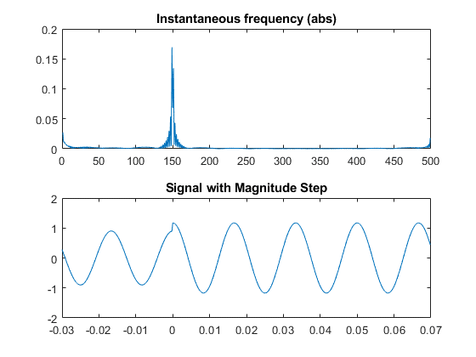

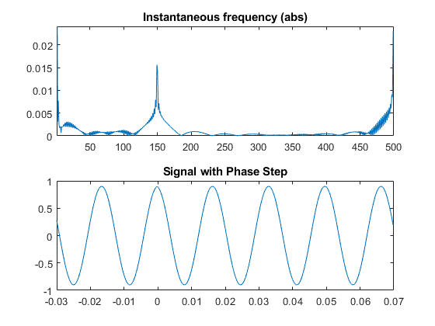

Fig. 2 - Instantaneous frequency of signal with one phase step

A simulation with digitally generated signals was performed to determine the errors obtained. The signals were created based on equations 1 and 2 with a 5kHz sampling frequency, with a duration of 0.1s, containing 6 cycles of 60 Hz. The magnitude was normalized to 1V, the magnitude step size was ±10%, the phase step size was ±10°, and the phase was set to 0°, 120°, or -120°. The peaks were detected taking the maximum value of the IF subtracted by its median value. For a total duration of the window *T*, , and , the maximum absolute errors are not greater than one , if we use nominal frequency.

A second simulation was made to allow 500 ppm variation in frequency and 1% variation in the other parameters. The maximum errors obtained are not greater than 2 for a .

### IV. Parameters estimation

The estimation of phasor parameters considering variations in frequency requires dealing with a non-linear function. Existing calibration systems solve this problem for steady-state signals through first order Taylor linearization [3], or using directly some non-linear minimization algorithm, e.g., Levenberg-Marquardt (LM) [4].

Consider samples from a sequence which can be either generated via computational simulation or sampled from measured real phenomenon, with uniform sampling period . One wishes to fit the models (see Section II) with parameters to For that, one can define the error cost function

, (4)

and try to solve the minimization problem

The Levenberg-Marquardt (LM) algorithm is an iterative technique for nonlinear minimization problems. It combines the Gauss-Newton method and the steepest descent and is very useful when the size of the algorithm step cannot be obtained in a closed form. Such NL-LS methods can reach local minima and need a convex cost function.

Figure of the cost function

Maybe explain more about LM

To check if the convergence is acceptable within certain limits, taking into account the uncertainties of the system and different noise levels, a Monte Carlo simulation was performed with 1000 iterations for each SNR. For this analysis, the step discontinuities occur in the middle of the window ().

For each Monte Carlo iteration, is generated with uncertainties added to the parameters, drawn from a uniform distribution centered around the nominal values, as shown in the upper part of Table I, where **d** is the interval of the uniform distribution, given in ppm. In the iterative LM algorithm, the model parameters are initiated at the nominal values, and the optimization procedure seeks for the minimum point of which is reached at the actual values of the parameters. In all simulations the sampling frequency was set to 4800 Hz, and the analysis window covers 6 cycles of the nominal phasor. The maximum errors obtained are shown in the lower parts of Table I. One can see that, for both tests, the estimation of the step discontinuity parameters are the most sensitive to the SNR. Moreover, they exhibit the highest maximum errors.

Table I- Parameter estimation maximum errors as a function of the SNR

|  |  |  |  |  |  |  |  |  |  |  |
| --- | --- | --- | --- | --- | --- | --- | --- | --- | --- | --- |
| **Parameter** |  |  |  | |  | | |  | | |
| **Nominal** | 100 V | 0.1 | 10° | | 60 Hz | | | 120° | | |
| **d[ppm]** | | | | 200 | | 200 | 200 | | 100 | 100 | |
| **SNR** | | | | **Magnitude Step Tests maximum errors [ppm]** | | | | | | | |
| 97 | | | | 0.98 | | 12 | - | | 0.077 | 0.30 | |
| 95 | | | | 0.95 | | 15 | - | | 0.086 | 0.33 | |
| 93.5 | | | | 1.2 | | 20 | - | | 0.087 | 0.50 | |
| 92.5 | | | | 1.5 | | 19 | - | | 0.087 | 0.53 | |
| 90.5 | | | | 1.8 | | 32 | - | | 0.15 | 0.50 | |
| **SNR** | | | | **Phase Step Tests maximum errors [ppm]** | | | | | | | |
| 97 | | | | 0.54 | | - | 16 | | 0.13 | 0.67 | |
| 95 | | | | 0.71 | | - | 19 | | 0.17 | 0.69 | |
| 93.5 | | | | 0.89 | | - | 22 | | 0.18 | 1.0 | |
| 92.5 | | | | 0.96 | | - | 23 | | 0.18 | 1.2 | |
| 90.5 | | | | 1.1 | | - | 28 | | 0.22 | 1.4 | |

The uncertainties of some parameters seem to be correlated. For example, in the phase step test model, the uncertainty in the

angular frequency ( estimation (all other parameters kept constant) has a quadratic relation with the maximum error obtained for the magnitude parameter , as shown in Fig. 3.

Fig. 3 - Maximum error of the magnitude parameter as a function of the frequency uncertainty

V. Reference values

After one estimates the model parameters, the problem of obtaining one phasor that represents the waveform arises. Instead of considering the values estimated from the adjacent

windows, one alternative proposal could be an intermediate value for magnitude or phase. The concept is illustrated in Fig. 4, where the phasor V1 represents the waveform during an initial steady state, Ve is a phasor representative of an intermediate state during the occurrence of a magnitude or phase step, and V2 represents the signal in the final steady state condition.

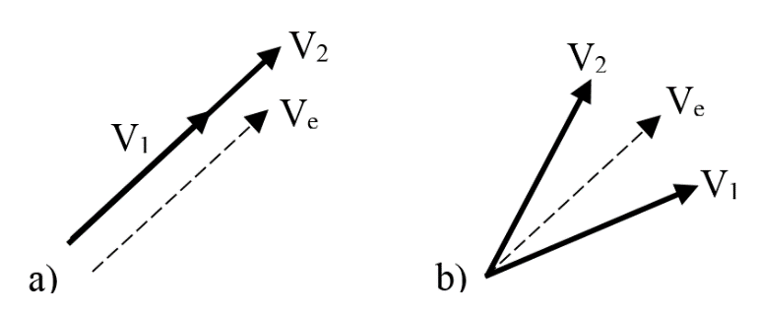

Fig. 4 - Transitioning phasors for a) magnitude step, b) phase step

That can be obtained, for example, using a weighted means out of the model parameters. For any , for a waveform with magnitude step described by equation (1), the intermediate magnitude would be

; (5)

and for a waveform with a phase step test described by equation (2), the intermediate phase would be

. (6)

To estimate the sensitivity of magnitude and phase obtained by the methods described in the last sections, a Monte Carlo simulation was performed, with SNR of 90.5 dB, the uncertainties indicated in Table I, and also considering errors in the estimation of of ±. The simulation was repeated for (same conditions of section III) : 12 situations in the standard.

The maximum errors obtained were not greater than 2 ppm in every prescribed situation. Then, considering this value as the uncertainty contribution of the estimator is a conservative approach.

VI. Laboratory Measurements

Aiming at validating the proposed method with real signals, several measurements were made using one digital sampling voltmeter (DSVM) and one arbitrary waveform generator (AWG), controlled by a personal computer (PC) via GPIB. The connections are shown in the block diagram of Fig. 1.

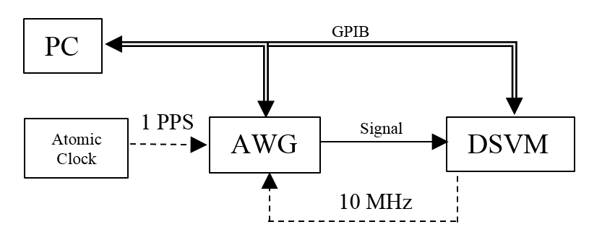

Fig. 5 - Block Diagram

The same waveforms used in simulations are reproduced by the AWG, with a nominal output of 1 Vpp, and sampled by the DSVM. Both are triggered with a 1 PPS (pulse per second) signal, coming from an atomic clock, so we can control the initial phase. The internal clock from the DVM is used as an external 10MHz reference signal by the generator. 5000 samples are taken during 1 s and stored in the DVM´s internal memory.

The standard [] establishes that the synchrophasors must be obtained related to the center of a window. Setting 500 samples/window, the first complete window will happen after 250 samples, after which we have 9 windows containing 6 cycles of 60Hz. The steps of magnitude or phase occur in the 5th window, as shown in . According to the procedure for equivalent sampling, the instants of occurrence of the steps are a set of equally spaced intervals .

The intermediate phasors for each waveform were calculated using equations (5) and (6), after obtaining the parameters using the Hilbert algorithm for the step instant, and the-LM algorithm for the others. The frequency was obtained directly from the LM estimation.

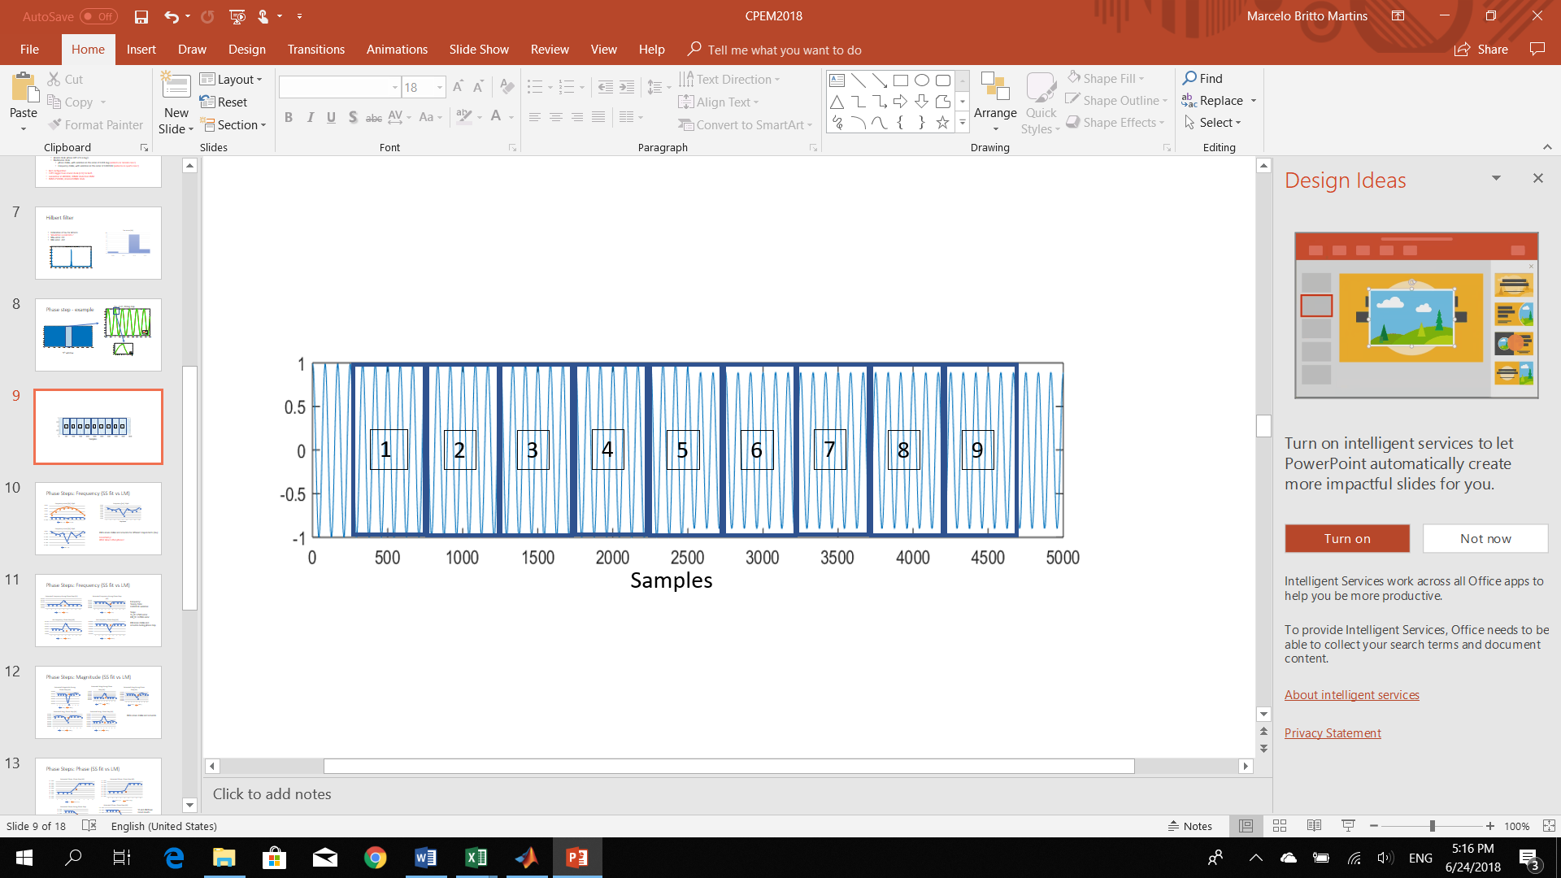

Fig. 6 - Magnitude step occurrence in the 5th window

The estimates of step instant were not greater than 2, inside the expected uncertainty. The other parameters require a more detailed analysis.

## *Magnitude Steps*

Magnitude Steps

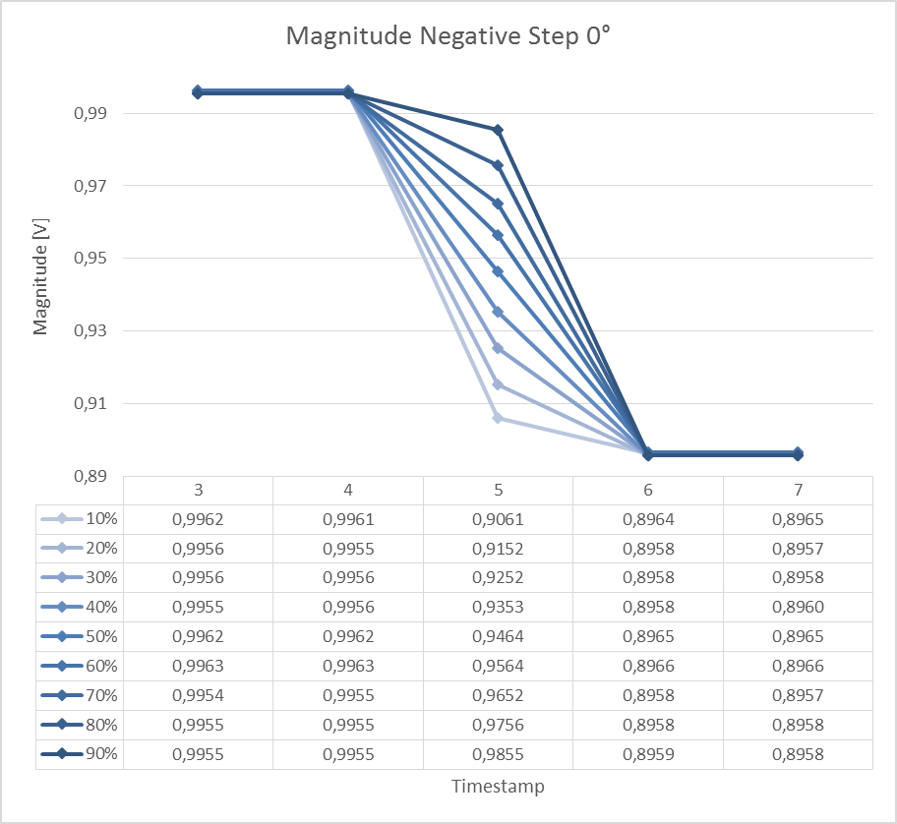

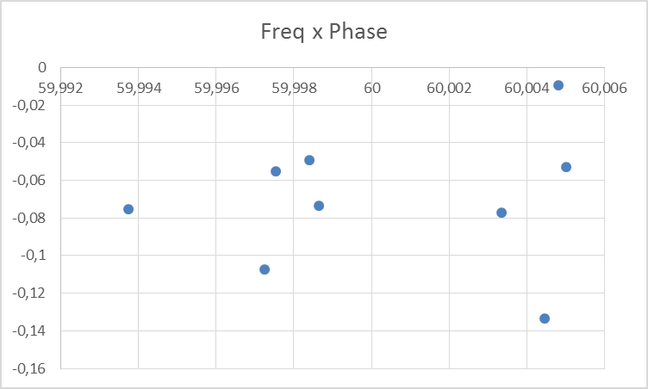

## *Phase Steps*

Phase Step

The frequency was much more stable during phase tests,

Discuss the results, uncertainties, estimation parameters

V. Conclusion

Models for phasor signals disturbed by magnitude and phase step discontinuity were proposed, in the context of assessment of PMU calibration systems in transient conditions. Estimation of the model parameters via a nonlinear least-squares method was outlined. The proposed approach tackles the estimation of the step discontinuities in the phasor signal observed within an analysis window, instead of dodging the problem. Moreover, single phasor parameters are proposed for transient conditions.

The estimation accuracy of each parameter was obtained under different noise conditions and uncertainties forced upon the model used to generate the test signals. Cross-correlated uncertainties were found, which point out to the need of a deeper investigation and the possibility of further improvements in the estimation performance.

Within the limits reported, the proposed method can give reliable and accurate results to be used in PMU calibration systems, avoiding procedures to adjust windows and time-stamps around the instant of step occurrence.

### Acknowledgement

I would like to thank Allen Goldstein~~,~~ for the valuable comments and guidelines.

### References

[1] *IEEE Standard for Synchrophasor Measurements for Power Systems*, IEEE Std C37.118.1-2011*,* Dec. 2011

[2] D. Colangelo *et al*., "Architecture and characterization of a calibrator for PMUs operating in power distribution systems," *2015 IEEE Eindhoven PowerTech*, Eindhoven, 2015.

[3] Y. H. Tang, G. N. Stenbakken and A. Goldstein, "Calibration of Phasor Measurement Unit at NIST," in *IEEE Transactions on Instrumentation and Measurement*, vol. 62, no. 6, pp. 1417-1422, June 2013.

[4] Frigo, Guglielmo, et al. "Definition of accurate reference synchrophasors for static and dynamic characterization of PMUs." *IEEE Transactions on Instrumentation and Measurement* 66.9 (2017): 2233-2246.

[5] ESTE MESMO no cpem

[6] Caciotta, M., et al. "Detection of short transients and interruptions using the Hilbert transform." in *Proc. 19th IMEKO World Congr. Fundam. Appl. Metrol.. 2009*.

[7] Edit Detection in Speech Recordings via Instantaneous Electric Network Frequency Variations